Chris Noonan

9 July 2023

Assignment 4.3

ORD:

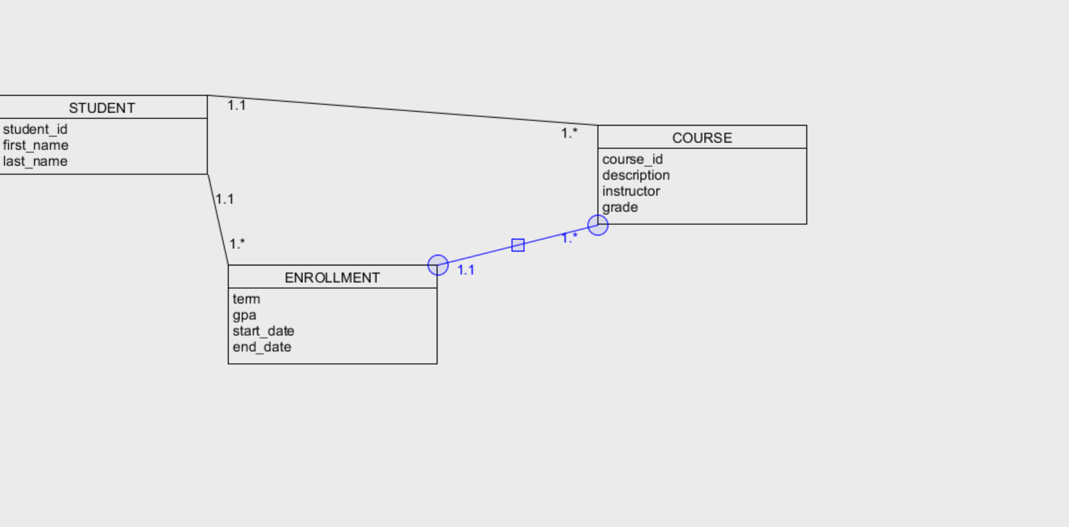

NoSQL:

